**Coding Challenge: Car Rental System**

**1. Update the daily rate for a Mercedes car to 68.**

UPDATE Vehicle

SET dailyRate = 68.00

WHERE make = 'Mercedes';

select * from vehicle;

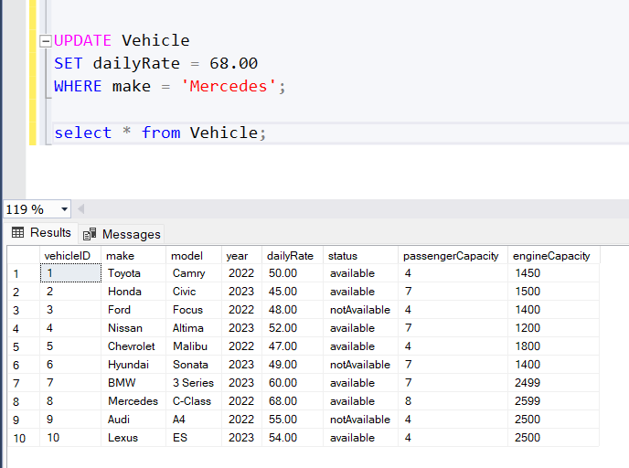

**2. Delete a specific customer and all associated leases and payments.**

DELETE FROM Payment

WHERE leaseID IN (SELECT leaseID FROM Lease WHERE customerID = 3);

DELETE FROM Lease

WHERE customerID = 3;

DELETE FROM Customer

WHERE customerID = 3;

select * from payment;

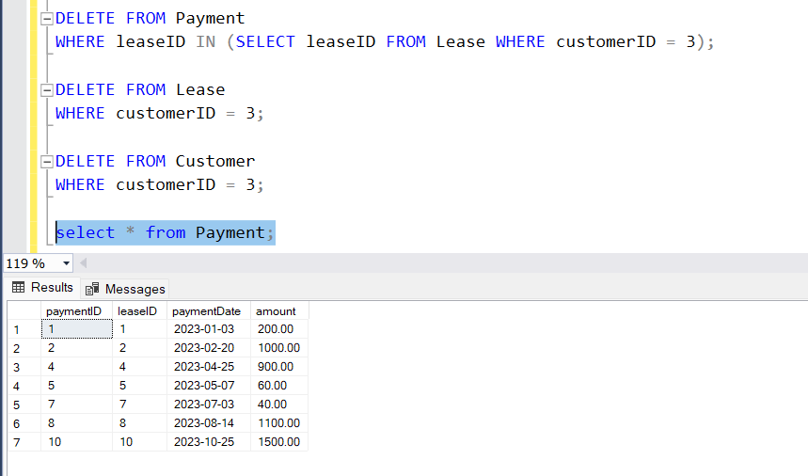

**3. Rename the "paymentDate" column in the Payment table to "transactionDate".**

EXEC sp_rename 'Payment.paymentDate', 'transactionDate', 'COLUMN';

select * from payment;

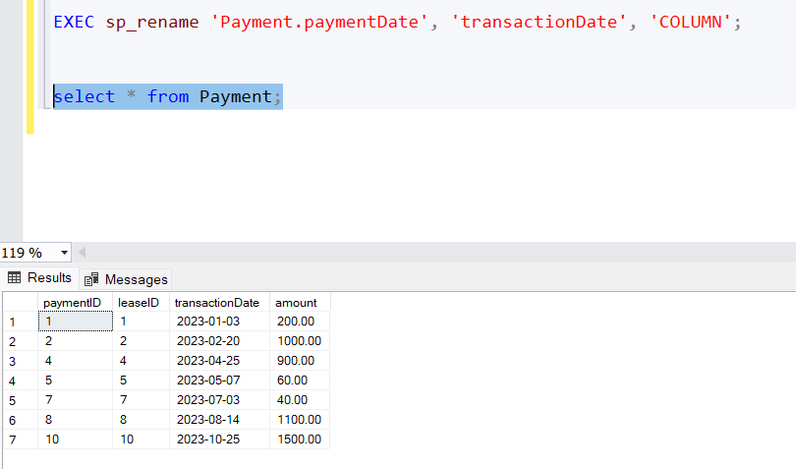

**4. Find a specific customer by email.**

SELECT *

FROM Customer

WHERE email = 'sarah@example.com';

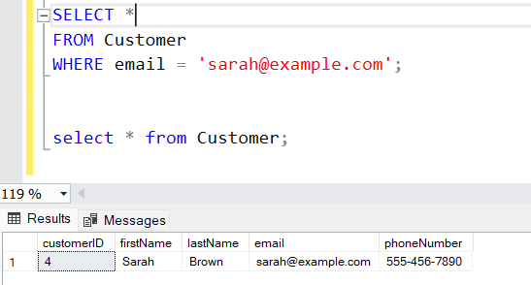

**5. Get active leases for a specific customer.**

DECLARE @currentDate DATE = '2023-05-06';

SELECT DISTINCT C.customerID, C.firstName, C.lastName, C.email, C.phoneNumber

FROM Lease L

JOIN Customer C ON L.customerID = C.customerID

WHERE @currentDate BETWEEN L.startDate AND L.endDate;

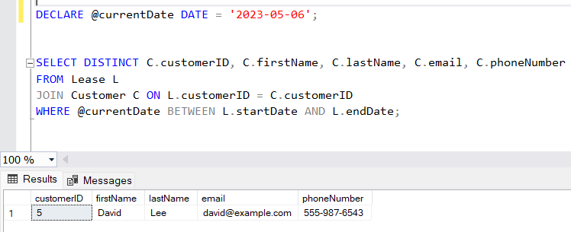

**6. Find all payments made by a customer with a specific phone number.**

DECLARE @phoneNumber NVARCHAR(20) = '555-456-7890';

SELECT P.paymentID, P.leaseID, P.transactionDate, P.amount

FROM Payment P

JOIN Lease L ON P.leaseID = L.leaseID

JOIN Customer C ON L.customerID = C.customerID

WHERE C.phoneNumber = @phoneNumber;

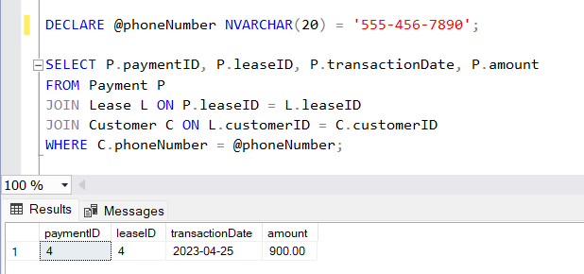

**7. Calculate the average daily rate of all available cars.**

SELECT AVG(dailyRate) AS averageDailyRate

FROM Vehicle

WHERE status = 'available';

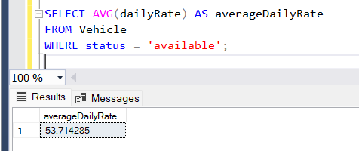

**8. Find the car with the highest daily rate.**

SELECT TOP 1 *

FROM Vehicle

ORDER BY dailyRate DESC;

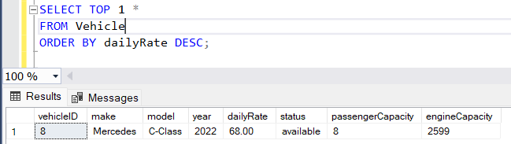

**9. Retrieve all cars leased by a specific customer.**

SELECT V.* FROM Vehicle V

JOIN Lease L ON V.vehicleID = L.vehicleID

JOIN Customer C ON L.customerID = C.customerID

WHERE C.phoneNumber = '555-456-7890';

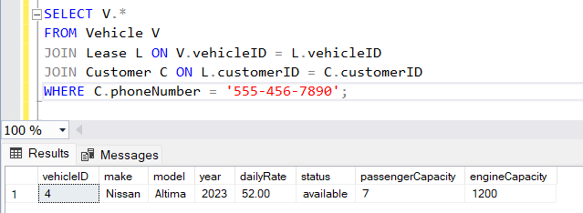

**10. Find the details of the most recent lease**.

SELECT TOP 1 *

FROM Lease

ORDER BY endDate DESC;

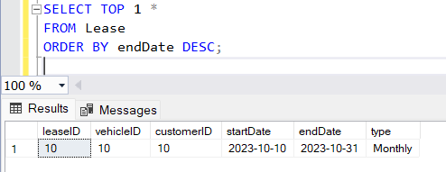

**11. List all payments made in the year 2023.**

SELECT *

FROM Payment

WHERE YEAR(transactionDate) = 2023;

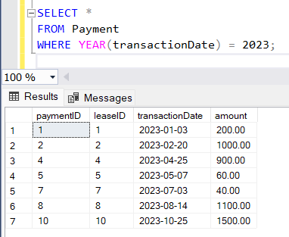

**12. Retrieve customers who have not made any payments.**

SELECT C.*

FROM Customer C

LEFT JOIN Lease L ON C.customerID = L.customerID

LEFT JOIN Payment P ON L.leaseID = P.leaseID

WHERE P.paymentID IS NULL;

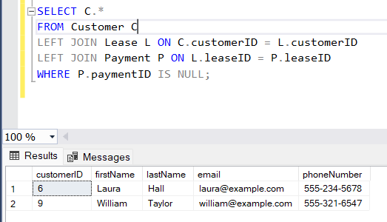

**13. Retrieve Car Details and Their Total Payments.**

SELECT V.vehicleID, V.make, V.model, V.year, V.dailyRate,

ISNULL(SUM(P.amount), 0) AS totalPayments

FROM Vehicle V

LEFT JOIN Lease L ON V.vehicleID = L.vehicleID

LEFT JOIN Payment P ON L.leaseID = P.leaseID

GROUP BY V.vehicleID, V.make, V.model, V.year, V.dailyRate

ORDER BY V.vehicleID;

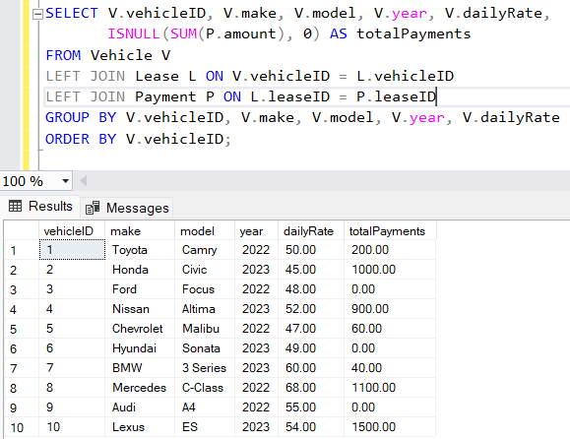

**14. Calculate Total Payments for Each Customer.**

SELECT C.customerID, C.firstName, C.lastName, C.email, C.phoneNumber,

ISNULL(SUM(P.amount), 0) AS totalPayments

FROM Customer C

LEFT JOIN Lease L ON C.customerID = L.customerID

LEFT JOIN Payment P ON L.leaseID = P.leaseID

GROUP BY C.customerID, C.firstName, C.lastName, C.email, C.phoneNumber

ORDER BY C.customerID;

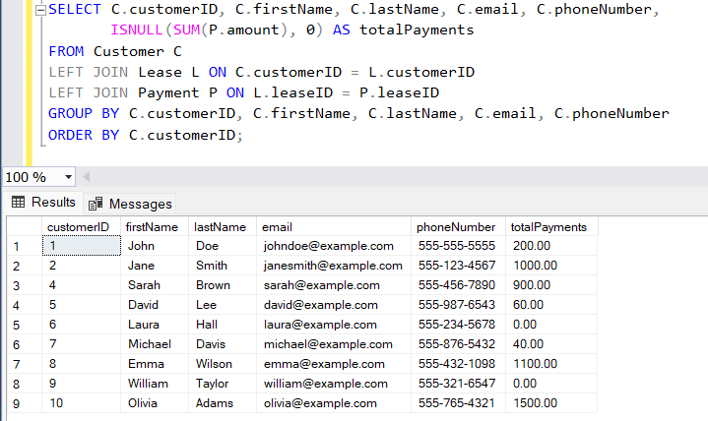

**15. List Car Details for Each Lease.**

SELECT L.leaseID, L.vehicleID, L.customerID, L.startDate, L.endDate, L.type AS leaseType,

V.make, V.model, V.year, V.dailyRate, V.status, V.passengerCapacity, V.engineCapacity

FROM Lease L

JOIN Vehicle V ON L.vehicleID = V.vehicleID

ORDER BY L.leaseID;

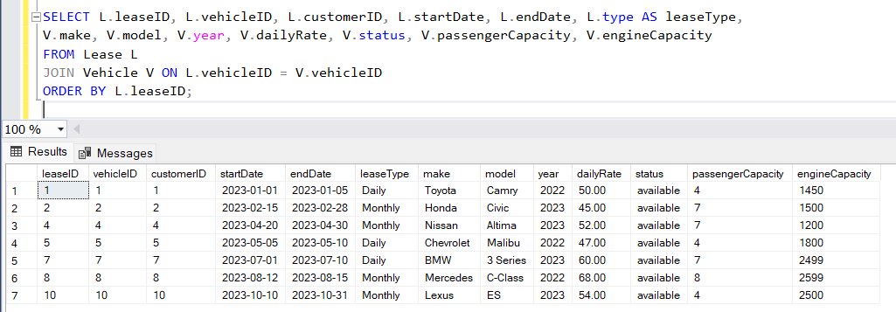

**16. Retrieve Details of Active Leases with Customer and Car Information.**

DECLARE @currentDate DATE = '2023-05-06';

SELECT L.leaseID, L.vehicleID, V.make, V.model, V.year, V.dailyRate,

L.customerID, C.firstName, C.lastName, C.email, C.phoneNumber,

L.startDate, L.endDate, L.type AS leaseType

FROM Lease L

JOIN Vehicle V ON L.vehicleID = V.vehicleID

JOIN Customer C ON L.customerID = C.customerID

WHERE @currentDate BETWEEN L.startDate AND L.endDate

ORDER BY L.leaseID;

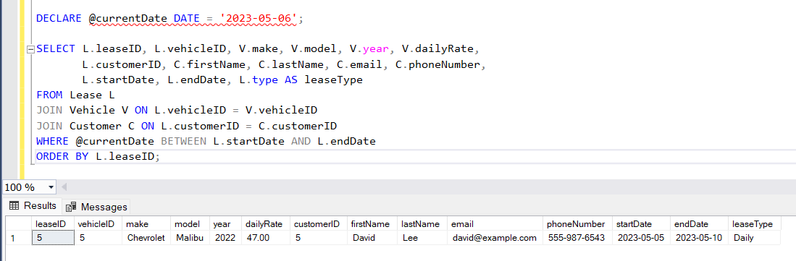

**17. Find the Customer Who Has Spent the Most on Leases.**

SELECT TOP 1

C.customerID,

C.firstName,

C.lastName,

C.email,

C.phoneNumber,

SUM(P.amount) AS totalSpent

FROM Customer C

JOIN Lease L ON C.customerID = L.customerID

JOIN Payment P ON L.leaseID = P.leaseID

GROUP BY C.customerID, C.firstName, C.lastName, C.email, C.phoneNumber

ORDER BY totalSpent DESC;

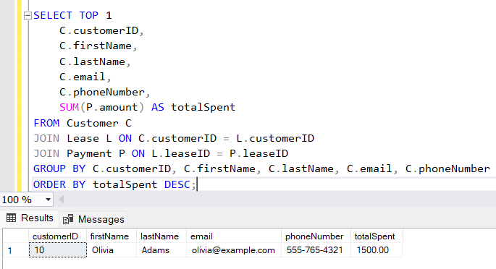

**18. List All Cars with Their Current Lease Information.**

declare @date date = '2023-05-06'

SELECT

V.vehicleID,V.make,V.model,V.year,V.dailyRate,V.status,L.leaseID,L.customerID,L.startDate,L.endDate,L.type AS leaseType

FROM Vehicle V

LEFT JOIN Lease L ON V.vehicleID = L.vehicleID

AND @date BETWEEN L.startDate AND L.endDate;

